THE DRAWING(S) AND THE INFORMATION CONTAINED HEREIN ARE THE PROPERTY OF WOOJIN INDUSTRIAL SYSTEMS CO., LTD. THEY SHALL NOT BE DISCLOSED, REPRODUCED OR USED, IN ANY MANNER WITHOUT THE PRIOR WRITTEN CONSENT OF WOOJIN INDUSTRIAL SYSTEMS CO., LTD. |  | Woojin’s Scope of Supply for wayside
DISTRIBUTION |  | R  E  V  I  S  I  O  N
 |  | R  E  V  I  S  I  O  N | 0 | Jan. 6, 2012 |  | First Issued |  |  | D.B. LEE | D.S. JANG | B.J. JONE | E.K. LEE
 |  | R  E  V  I  S  I  O  N | No. | ISSUED  DATE |  | REVISION NOTE |  |  | DESIGNED | CHECKED | APPROVED | REVIEWED
 |  |  |  |  |  |  |  |  | ENGINEERING |  |  | PM
 |  | PM |  |  | REVIEWED |  | E.K. LEE |  | CUSTOMER :
 |  | ENGINEERING |  |  | APPROVED |  | B.J. JONE |  | HYUNDAI ROTEM COMPANY
 |  |  |  |  | CHECKED |  | D.S. JANG
 |  |  |  |  | DESIGNED |  | D.B. LEE |  | PROJECT :
 |  | ISSUED DATE |  |  | January 6, 2012 |  |  |  | DENVER RTD EAGLE P3  COMMUNICATION SYSTEM
 |  | ISSUED BY |  |  | R & D CENTER
 |  | PROJECT NO. |  |  | P2011-020
 |  | ORDER NO. |  |  | P110701149 |  |  |  | 
 |  | DOCUMENT NO. |  |  |  |  |  | REVISION
 |  | 42A-2012-0006 |  |  |  |  |  | 0
TOTAL |  |  |  |  |  |  |  | 0
REVISION RECORD
Rev. No. | PAGE | Details |  | Date
Rev. No. | PAGE | FROM | TO | Date
0 | - | First Issued |  | January 6, 2012
Table of Contents

1. Scope of Supply for the MDS DATA Management 5
1.1 HR/Woojin’s scope. 5
1.2 The other scope. 5
2. Scope of Supply for the Automatic Announcement 6
2.1 HR/Woojin’s scope. 6
2.2 The other scope. 6
3. Scope of Supply for the Content DATA Function 7
3.1 HR/Woojin’s scope. 7
3.2 The other scope. 7

Appendix A
Abbreviations
DPO | Driver PA Operation Box
CPO | Conductor PA Operation Box
PEI | Passenger Emergency Intercom
OCC | Operations Control Center
CSP | Cab Speaker

Scope of Supply for the MDS DATA Management

HR/Woojin’s scope.

Woojin’s scope of supply for Wayside are the on-board communications system.
(Supplies the scope colored with yellow.)

Manages the MDS transmission from the vehicle to the OCC.

The other scope.

DENVER RTD should decide who will supply the server which will store the MDS file.

DENVER RTD should decide who will manufacture the application program which will manage the MDS file in the OCC server.

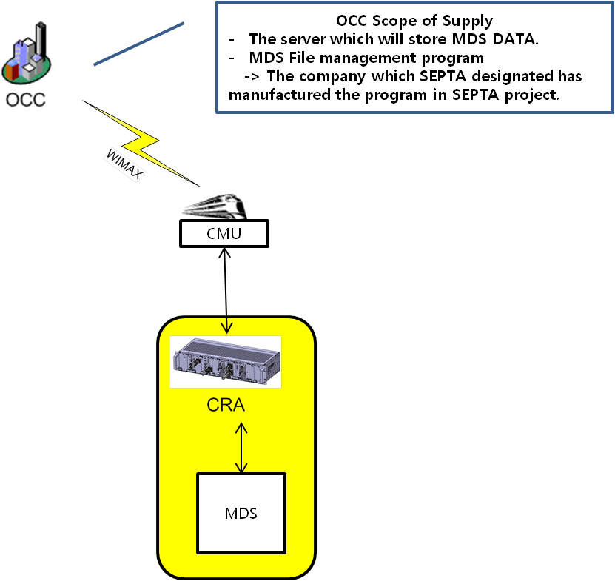

Scope of Supply for the Automatic Announcement

HR/Woojin’s scope.

Woojin’s scope of supply for Wayside are the on-board communications system and the software which edits the schedule data needed for operating.
(Supplies the scope colored with yellow.)

The other scope.

DENVER RTD should inform Woojin that who will supply the GPS data necessary for the automatic announcement.

Woojin should know the GPS data of the system design. Woojin would like to have an interface meeting with the GPS supplier in a short time.

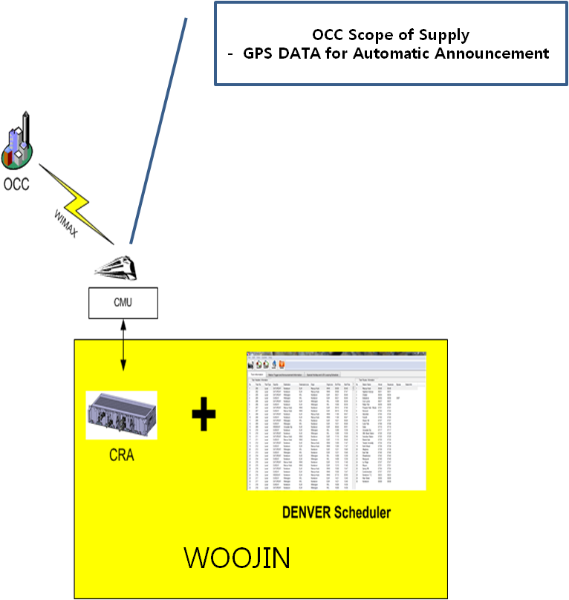

Scope of Supply for the Content DATA Function

HR/Woojin’s scope.

Woojin’s scope of supply for Wayside are the on-board communications system.

Woojin supplies the application program which manages the Content file in the OCC server.
(Supplies the scope colored with yellow.)

The other scope.

DENVER RTD should decide who will supply the OCC server which will store the MDS file.

